**ENERGY COMMUNITY ROADMAP**

**Municipality of Gabrovo**

**Name: Todor Popov**

**Disclaimer**

The sole responsibility of this publication lies with the authors and reflects only the authors’ view. Views and opinions expressed do not necessarily reflect those of the European Commission or CINEA. Neither the European Union nor the granting authority can be held responsible for them.

The LIFE LOOP Consortium as a whole nor any individual party, does not offer any assurance that the information presented in this document is suitable for immediate use and will accept no liability for any loss or damage experienced by any person and/or entity using this information.

#### Introductory Remarks

The community energy roadmap is a **collaborative and wide-participatory strategic plan** that aims to contribute to the effort of local municipalities to create sustainable and successful Energy Communities which will constitute the leading tool for the local democratic energy transition. A roadmap for a municipality allows all the participating stakeholders to make the best use of the locally available renewable energy resources, benefit from the related advantages and drastically reduce the impact of the energy crisis, and climate change on their community. Furthermore, through the community energy roadmap, a municipality can strategically plan and monitor the development of an enabling framework and subsequent support measures for the creation and advancement of the local citizen-led initiatives, Energy Communities, and community energy projects.

The energy road map of Gabrovo Municipality is tailored to the specific local needs and specificities. It focuses and directs relevant efforts and actions towards a common vision. This strategic plan analyses the dynamics of the local community, formulates objectives and develops alternative pathways, actions and strategies to achieve the shared vision.

The objective of this guide is to propose a potential strategic planning structure for the democratic energy transition, supporting and promoting the participation of people of all genders on equal terms.

ROADMAP

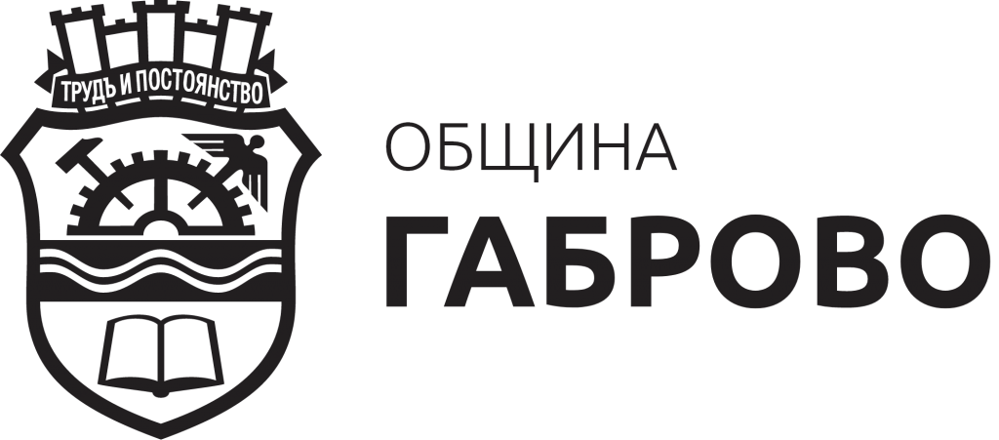

**Author:**

Todor Popov

Mariya Radoycheva

Zhana Bastreva

Supported by EnEfect

# Part I: Local Context

# *Gabrovo Municipality is a partner in the implementation of the European LIFE LOOP project, a project whose main goal is the creation of local energy communities through the implementation of investment projects with the participation of citizens. Gabrovo Municipality is among the leading municipalities in the field of energy efficiency and sustainable development. Part of 100 cities included in the European Union’s Climate Neutral and Smart Cities Mission.*

# *The goal of Gabrovo Municipality is to build, maintain and upgrade capacity in the field of support and promotion of energy communities, as well as to create an appropriate environment for active process towards creating partnerships between citizens and institutions for the active participation of citizens in the green transition. The ability to map and replicate the experience of leading partners, as well as the use of different resources, will contribute to achieving these objectives.*

# *The high ambitions to launch renewable energy (sun) projects of EUR 500000 require support for community energy to be stimulated through the development of a new Community energy policy.*

# *The lack of experience in the field of energy communities – both technical for the implementation of projects and administrative ones, implies a clear indication of the path along which the Municipality of Gabrovo will be developed, and a unified vision for this will be needed.*

*The development of an energy roadmap is key to systematising the high ambitions and objectives set by the Municipality of Gabrovo on the path towards climate neutrality and green transition. Gabrovo municipality high ambitions are embedded in: The Covenant of Mayors; the ambition of Gabrovo Municipality to be a climate neutral municipality by 2030; Integrated Development Plan of Gabrovo Municipality and others.*

*The road map aims to point out the path of Gabrovo Municipality, supporting and developing the energy transition, starting from reducing energy consumption, shifting from fossil fuels to renewable energy, involving local communities and their associations to achieve sustainable solutions, with a lasting impact on the community – environmental, social and economic. The road map set specific objectives for achievement.*

*The systematisation of the different resources – natural (potential renewable energy sources), financial (different financial instruments and financiers), expert (stakeholders with different competences and knowledge), organisational and others, needs to be done. This will make the needs of different stakeholders visible, and by creating or using matchmaking tools, they will be able to connect to meet their needs and realise joint projects.*

*On the other hand, clear targets will be used in future decision-making for policy-making and investment of time and resources in one direction or another with socially vulnerable groups, energy poor, but also helping citizens who have a certain degree of readiness and need support to implement projects in the field of energy efficiency and renewable energy. To this end, one-stop-shop (OSS) or technical or administrative support projects can be developed.*

|  |  |  |
| --- | --- | --- |
| *Field of intervention* | *Subject of impact* | *Stakeholders* |
| *Energy efficiency* | *Multifamily building**Transport* *Equipment* | *Owners of building**Individual citizens/business* *citizens* |
| *Renewable energy* | *Production of clean energy* | *Citizens/business* *NGOs**Grid operator**Scientific organizations**Universities**Start-ups* |
| *Awareness raise* | *Administrative capacity* *Citizen knowledge* | *Public authorities* *Education organizations*  *NGOs*  *Citizens* |

# Part II: The Leadership Team

*Tanya Hristova – Mayor*

*Todor Popov – Director of Administrative Legal and Information Services (founder of the First Energy Community)*

*Maria Radoycheva and Jana Bastreva – experts working with citizens and citizens’ initiatives*

*Stiliana Ivanova – expert*

*Venelin Ganchev – expert*

*Representing associations of the owners of independent objects in many family residential buildings*

*Experts in the field of energy efficiency*

*Experts in the field of renewable energy*

*The team includes representatives involved in political decision-making, which signals support at the political level for the realisation of the roadmap. On the other hand, it gives confidence to the participants that decisions towards its implementation that need political support can rely on it.*

*The experts from municipal administration cover the main areas of impact and competences, and have the support of other colleagues around whom the necessary administrative capacity will be built and implemented.*

*The inclusion of representatives of civic circles – owners of objects in multi-family residential buildings, implies the participation of a large part of the society, and the proposed solutions – the possibility of multiplication and implementation by a large number of persons.*

*Experts in the two main directions – energy efficiency and renewable energy will be attracted to specific tasks – from increasing the capacity and knowledge of citizens and employees, to demonstrating solutions and their implementation.*

## Part III Establish the Local Context and Potential

## Local Potential

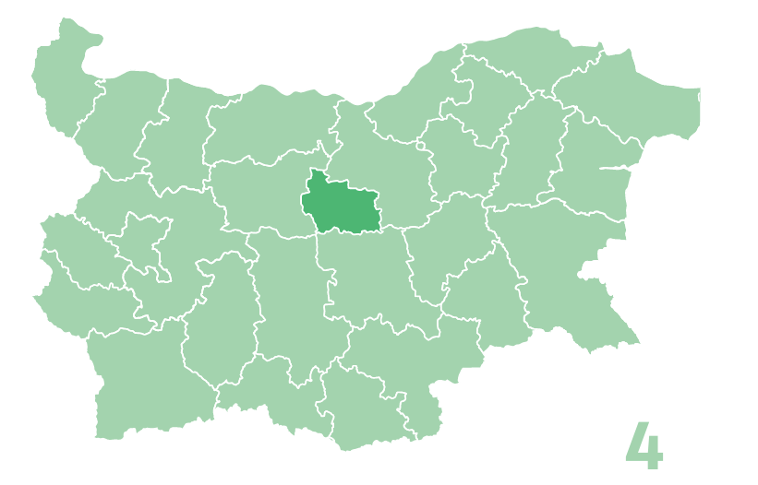

*The municipality of Gabrovo is located in the center of northern Bulgaria, with the Yantra River stretching along the entire length of the city. There are 134 settlements on the territory of Gabrovo Municipality. The city of Gabrovo is about 200 km from the city of Sofia. In the immediate vicinity of it, in the "Uzana" area, is the geographical center of Bulgaria. The geographical location of the Municipality of Gabrovo determines the availability of prerequisites for the priority development of certain activities. According to the bioclimatic classification and the general assessment of the natural conditions, Gabrovo is in a zone of favorable environment for habitation with prevailing comfortable climatic conditions. Taking into account the economic and complex efficiency of construction, including the preservation of forest parks and other forest massifs, the city's territory is globally structured into residential areas above 500 m above sea level and a recreation area above 600-800 m above m. r.*

*The main favorable aspects of the geostrategic position of the Municipality of Gabrovo for the development of the economy in the region are its crossroads location and good transport security.*

*The municipality is located on the river terraces of the rivers Yantra, Sinkevitsa, Panicharka, Zhalteshka and Lopushnica. The lowest altitude for the Municipality as a whole is 150 m, and the highest 1495 m.*

*The climate in the area is moderate-continental. The municipality of Gabrovo falls within the region of the Pre-Balkan sub-mountainous and low-mountain climate region of the Moderate continental climate sub-region of the European-continental climate region.*

*The municipality of Gabrovo has a developed, adopted and operational Plan for sustainable energy and climate, which reflects in detail the current state of the municipality, and its periodic monitoring and reporting contribute to updating the data. For this reason, the road map will not repeat the information and data available in* [*SECAP*](https://gabrovo.bg/files/Energy%20efficiency/gb-Predstavqne_na_plan.pdf)*.[1]*

*Renewable energy potential.*

***Resource assessment studies****:*

*The municipality has favourable conditions for renewable energy. According to the* [*simulated historical climate and weather data for Gabrovo*](https://www.meteoblue.com/bg/%D0%B2%D1%80%D0%B5%D0%BC%D0%B5%D1%82%D0%BE/historyclimate/climatemodelled/%D0%93%D0%B0%D0%B1%D1%80%D0%BE%D0%B2%D0%BE_%D0%91%D1%8A%D0%BB%D0%B3%D0%B0%D1%80%D0%B8%D1%8F_731549)*:*

1. *Cloudy, sunny and rainy days:*

*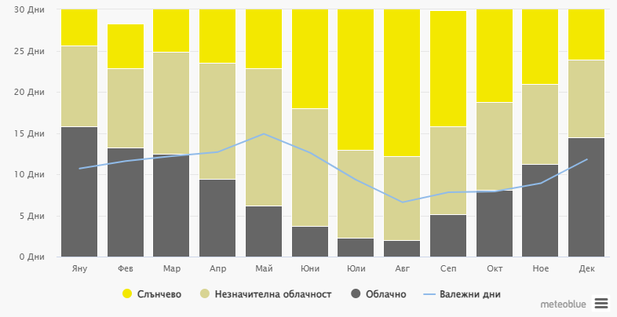The chart shows the number of sunny, partly cloudy, cloudy, and rainy days. Days with cloud cover below 20% are considered sunny, days with cloud cover between 20 and 80% are considered partly cloudy, and days with over 80% are considered cloudy.*

*Values ​​for the total solar radiation for the city of Gabrovo are presented in the following table, from which it is clear that the total solar radiation has a distinct annual trend, with a maximum in July and August.[2]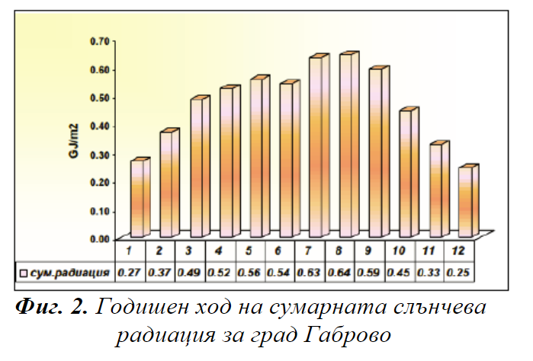*

1. *Waters: The location of Gabrovo along the river Yantra and the availability is a good prerequisite for the development of small and medium-sized hydropower plants.*
2. *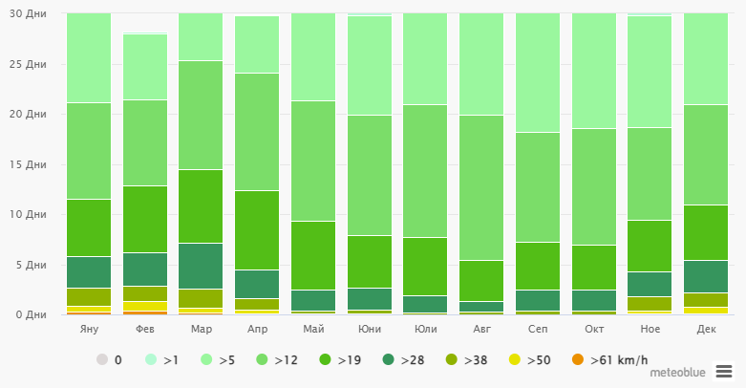Wind Speed the following diagram for Gabrovo shows the days of the month during which the wind reaches a certain speed*

*WIND ROSE: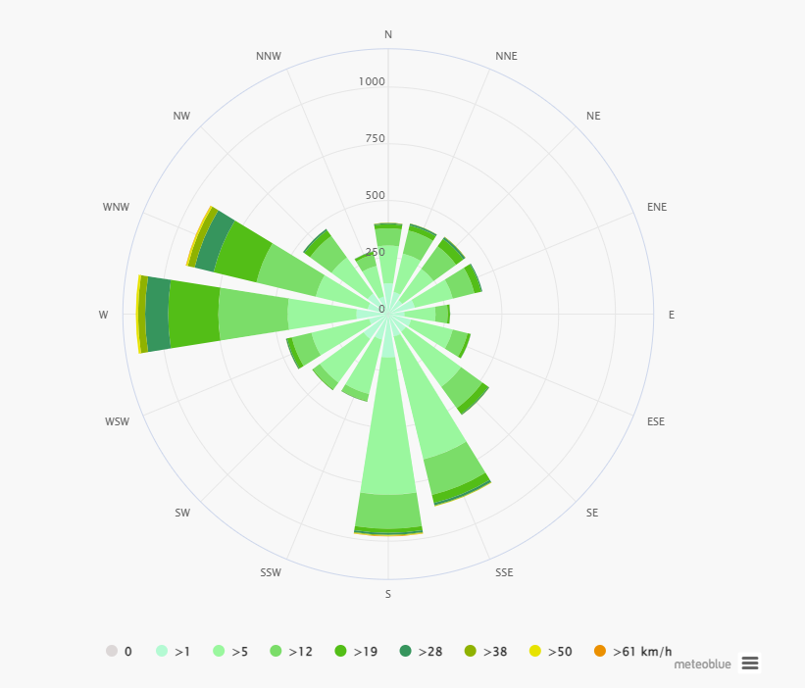*

*The wind rose for Gabrovo shows how many days per year the wind blows from a certain direction. Example SW: The wind blows from southwest (SW) to northeast (NE).*

*In conclusion, as well as the laid down in SECAP, we can summarize the potential of the Municipality of Gabrovo for the development of RES /Renewable Energy Sources/ on the territory of the municipality of Gabrovo shows that the municipality does not have a great potential for the development of big wind, geothermal and water energy plants. However, to the extent that energy communities have the advantage of using small installations to cover their own needs - it is of interest to study the possibilities for Urban Wind Turbines, as well as the possibility of using the potential of the Yantra River crossing the entire city.*

*With regard to photovoltaic plants, the conclusion was made that the construction of large photovoltaic capacities on the territory of Gabrovo municipality cannot be expected in the short term. What is realistic is, in the near future, to build small rooftop solar power plants, with an installed capacity of up to 30 kWp suitable for energy use by the owners of the plant or in a certain small community to utilize the overall amount of energy.*

*With the greatest potential for development is the production of energy from biomass. Existing examples of biomass use on the territory of Gabrovo municipality include: biogas plant from plant and animal substances, production of electrical and thermal energy from wood chips, use of biomass from household waste, sludge farm for WWTP.*

*There is a good environment for promoting and supporting energy communities for energy efficiency, insofar as there is a good basis and knowledge among citizens about the benefits of collective measures for energy efficiency as a result of the implemented National Program for Energy Efficiency in the period 2015-2018, as well as potential for future development due to the availability of financial instruments and programs to support the owners of multi-family residential buildings - National Recovery Plan and other programs with European or national funding.*

*/for more information GABROVO SECAP/*

### Energy Efficiency

Gabrovo Municipality has developed a Sustainable Energy and Climate Action Plan (SECAP), in which are presented the main energy consumers - generating harmful emissions. Periodically, a monitoring report is carried out and presented, which reflects by sectors and directions the reduction of harmful emissions compared to 2008. The current monitoring report [3]calculates the energy and GHG consumption in 2008 compared to 2020. The information in SECAP shows that total energy consumption by sector – 2008 and 2020 is as follows:

|  |  |  |  |
| --- | --- | --- | --- |
|  | 2008, MWh | 2020, MWh | Growth vs. 2008, % |
| Municipal buildings, equipment/facilities | 12 814.35 | 7 855.61 | -38.7 |
| Municipal street lighting | 3 111.67 | 2 925.35 | -6.0 |
| Residential buildings | 132 200.78 | 136 333.86 | 3.1 |
| Tertiary buildings, equipment/facilities | 18 820.17 | 12 446.81 | -33.9 |
| Municipal fleet of vehicles | 3 878.50 | 6 122.13 | 57.8 |
| Public transport | 5 540.00 | 6 442.85 | 16.3 |
| Private and commercial transport | 364 629.10 | 352 226.16 | -3.4 |
| TOTAL | 540 994.59 | 524 352.77 | -3.1 |

According to the monitoring report, the Municipality of Gabrovo is doing well, although not enough with regard to Municipal buildings, equipment/facilities and Tertiary buildings, equipment/facilities, with regard to Street lighting, a project for the introduction of energy efficiency measures through a guaranteed result contract was completed in 2022, and currently the electricity consumption for the last year has been reduced by 2 188.86 MWh or by 70% compared to 2008. As regards public transport, action has been taken to replace buses.

The municipal fleet has a negative trend, but the relative share of energy used is minimal.

An exceptional potential for introducing energy-saving measures is identified in residential buildings, and in particular in multi-family ones. Although the 2020 monitoring report shows a reduction in greenhouse gases generated by this sector, energy consumption is on a significant scale. A favorable opportunity for the implementation of energy efficiency measures is the European and national policy, as well as the upcoming transition from regulated (subsidized) electricity prices to liberalization of the household market. The availability of programmes and funding aimed at households should be used as a demonstration stage in which to demonstrate the benefits of energy efficiency, but also those of self-consumption and especially of shared production and use of energy - electricity, heating and cooling.

As a result of the targeted work of the municipality of Gabrovo with the support of the owners of residential buildings (multi-family) by the beginning of 2024, the municipality of Gabrovo has over 80 audits for energy efficiency of multi-family residential buildings, i.e. with pre-project readiness for the implementation of activities for the introduction of energy efficiency measures. Applying the principles of One-Stop-Shop service and learning from projects including LIFELOOP, it has improved its communication with citizens, the expertise of its employees and actively works with citizens to realize energy efficiency and introduce renewable energy sources. By seeking support from other projects to support OSS, for energy efficiency and renewable energy.

### Sustainable Mobility

In 2021, Gabrovo Municipality developed and adopted its Sustainable Urban Mobility Plan. A Sustainable Urban Mobility Plan is a strategic plan designed to meet the mobility needs of people and businesses in and around cities for a better quality of life. It shall build on existing planning practices and take due account of integration, participation and evaluation principles. The plan contains detailed and comprehensive information on the existing situation, the need and opportunities for urban mobility development, so that Gabrovo can become a connected, safe and peaceful city. The plan also contains specific measures and directions in which urban mobility should develop in the period 2021-2030, following in particular the principle of sustainability - social, economic and environmental.

The plan provides for a number of measures from pages 201-217, but the plan was adopted before the concepts such as energy communities entered Bulgaria, which is why most measures and projects target one leading entity and multiple users - public transport, road infrastructure, cycling, etc.

Initiatives based on community solutions could be potential to build on the measures in the plan:

* co-ownership of electric vehicles or other vehicles; development of smart applications for shared mobility with conventional or electric cars, which will lead to the reduction of cars with one passenger
* encouraging the taxi industry to use electric vehicles
* construction of public charging stations used free of charge or at a reduced fee by EC-owned electric vehicles or meeting public needs (taxi, social, freight forwarding), but at certain intervals - when "green" energy is generated.

## Key challenges for Gabrovo

*The municipality of Gabrovo has set extremely high goals for achieving carbon neutrality, which requires the involvement of more and more groups of interested persons, even the direct participation of citizens in topics such as energy transition, participation in the liberalized energy market. The closure of the local district heating company presented the local community with another challenge as more than 4,000 subscribers were left without heat supply, requiring the use of new tools and mechanisms to cover their heat energy needs. The data from the monitoring report of SEKAP show that the spheres in which it acts independently (street lighting, public buildings - schools, kindergartens, administrative buildings, etc., the buildings of private companies) achieve certain results dictated by socio-economic motives or political incentives and commitments, as the benefits but also the costs are in favor of one person.*

*This is not the case with collective causes - multi-family buildings, public transport, private transport, since the efforts and resources of many individuals are required, and the benefits are for the community and less tangible in the personal space - but in the long run it is these community solutions lead to the cessation of climate change and the achievement of the goals of sustainable development.*

*The main goal of the administration is to assist citizens in finding solutions for introducing energy efficiency measures in multi-family buildings (in single-family buildings, the cost-benefit principle applies in the same hands), since there are many social strata - energy poor, middle class, people who have already implemented energy efficient measures to a certain extent. It is in multi-family buildings and the problems are different even depending on which floor the object is on, very often a large part of the owners do not live permanently in their home.*

*Civil society should change its attitude towards common property, and for this purpose a good communication campaign should be built - with visualization and presentation of the benefits of community solutions, compared to independent actions.*

*Energy efficiency cannot lead to a complete lack of energy need, therefore an instrument should be found to guarantee an increasingly significant share of "green" energy for the household, however at an acceptable price. The expected increase in the prices of electric energy (the only energy that is in every home and building) and the rising prices for balancing it, for using the grid, will place an even larger part of the population in energy dependence (poverty). Demonstrating the benefits of citizen participation in the energy transition is a possible tool for socially acceptable solutions - those who have the resource at a lower profit to produce and deliver energy to the poor, as well as for social services and activities. An aging population implies more and more social services that require maintenance and use energy.*

*Consumer thinking and consumer behavior also leads to pollution with waste and greenhouse gases - shared vehicles would meet the needs - society should change its attitude.*

*The desire for possession and proprietary behavior is a product of our historical development, and any association with collective forms such as a cooperative evokes not so good associations. Good examples and enduring models are needed to make people feel comfortable participating.*

*However, the most important and essential challenge remains the building of trust (lost over the years) between public authorities and citizens, between citizens and businesses, but also between citizens themselves.*

## Partnerships, stakeholder, and citizen involvement

*An essential role for the achievement of the set goals is the attraction of the appropriate stakeholders, their engagement, as well as the construction of a sustainable network (ecosystem) between all participants in the processes.*

*We should distinguish the various actors and stakeholders into several groups*

*- Private sector: Property owners or managers (e.g. private condominiums), individual owners of residential buildings and associations of representatives of condominium managers. Energy users (although a broad term should be identified as interested parties and potential participants), producers of "green" energy - for own consumption and sharing, but also for commercial purposes, who can redirect and reorient their gaze towards energy supply to local users.*

*- public sector: Local authorities, regulators, public service providers (utility companies)*

*- Industrial partners: manufacturers, suppliers, contractors, etc. of installations for production, transmission and storage of energy, suppliers of solutions (smart) for energy management - systems for monitoring, control and management of building installations.*

*- financial and legal services: Banks, private investors, financiers, lawyers, ESCO companies*

*The selection of specific participants in each stage of the implementation of the activities will be based on their experience, influence and willingness to actively contribute to the achievement of the goals of this roadmap.*

*In addition to the implementation of specific tasks related to the introduction of energy efficiency measures or the implementation of systems for the generation, storage and use of "green" energy, the interested parties also have an important role in various phases, including, but not limited to:*

*· Provide insights and expertise during project planning and execution.*

*· Facilitating access to resources, finance and infrastructure.*

*· Participation in dissemination and replication efforts to extend the effect of implemented measures beyond the specific project.*

*By working closely with these stakeholders, the aim is to ensure that the goals and activities set out in this roadmap aimed at promoting the creation and existence of energy communities to achieve the larger goal of achieving a carbon net neutral city will be achieved.*

# Part IV: Concrete Steps–Turn your Vision into Action

## Developing Strategies

### Develop Clear, Attainable, and Measurable Goals

*In the previous year 2023, the municipality of Gabrovo carried out many activities to prepare, encourage and assist citizens in the implementation of energy efficiency measures and the introduction of installations for energy from renewable sources.*

*The set high goals for carbon neutrality in a relatively short period of time - 2030 requires the application of complex methods.*

*The main tool in this direction will be increasing the capacity of the administration through trainings and workshops, including for energy efficiency and energy communities (these were conducted at the end of 2023 by EnEffect), but they are far from sufficient. The energy efficiency center that has existed for years should be awarded and provide services related to both energy efficiency and energy from renewable sources.*

*The development of EC concepts and models of functioning should be a focus in the short term (1-2 years) to encourage their creation.*

*Identifying land suitable for the construction of installations for the production of energy from renewable sources is key for sustainable development, so that minimal amounts of useful areas (agricultural and other land) can be affected.*

*Refining the green energy acquisition process - green energy procurement\**

|  |  |  |  |  |  |  |
| --- | --- | --- | --- | --- | --- | --- |
|  | **Jan 2024** | **May 2024** | **Sept 2024** | **Jan 2025** | **May 2025** | **Sept 2025** |
| **Goal** | First energy community for “green” energy established | Energy sharing;  Upgrade the existing OSS | Citizen led initiatives for energy efficiency in multifamily building | Second energy community for “green” energy | Citizen led initiatives for energy efficiency in multifamily building | Replicated and adopted developed models  New model of purchased energy to be developed and presented. |
| **Activities** | development of a concept for the functioning of an Energy Community;  conducting an information campaign  carried out initiatives (workshops) to increase the capacity of the administration and citizens | study and mediation between interested parties, regarding the possibility of energy sharing between producer and consumer (within the EC);  Contract preparation | Information campaigned;  Administrative and technical support (OSS);  Develop new model of deep renovation; | development of a concept for the functioning of an Energy Community | Information campaigned;  Administrative and technical support (OSS);  Develop new model of deep renovation; | New procurement models to be tested: Buy from local community; Buy from a small producer. |
| **Predicted output** | One energy community established | Test the model | 10 EC (Citizen led initiatives) for multifamily renovation;  1 projects for deep renovation | Energy community established | 1 project for deep renovation | 10 contract for energy supply from new model – local producer green energy |
| **Community involvement** | Citizen, SMEs and municipality directly participated in EC | X | condominium associations | Citizen, local social/health entity, SMEs and municipality directly participated in EC | condominium associations | REC, citizens and public organization (schools, kindergartens etc.) |
| **Technology** | PV installation | Smart metering and energy balancing | Renovation;  Deep renovation with a heat pump; | PV installation | Deep renovation and heat pump | NA |
| **Installed RES capacity, MW** | 0,10 | 40,00 MW per year to be shared* | 0,15 | 0,15 | 0,15 | Not measurable at this level |
| **Renewable energy triggered, MWh/yr.** | 113 | 40,00 MW* | 95 | 150 | 95 | NA |
| **No renewable energy saved, MWh/yr.** | NA | NA | 2456 | NA | 480 | NA |
| **Stakeholders participating** | 73 | 5 | 120 | 100 | 120 | 100 |
| **Investments triggered, EUR** | 80 000 | NA | 2 500 000 | 100 000 | 500 000 | NA |

*The realization of the set goals is the result of combining knowledge and experience, built models and funding sources. The current road map sets its goals, relying both on already existing models and secured finances, but also on those that should be upgraded and tested even with the risk of not being realized.*

*The achievement of the objectives currently relies on building on the existing experience and**expertise. In the field of energy efficiency, one relies on the upgrading of both technical solutions and the involvement and commitment of the owners. The well-known and insufficient basic renovation models implemented entirely with 100 grants will be further developed by moving to a lower grant intensity but also to a higher energy efficiency class.*

*The introduction of renewable energy will rely on the development of new models of the operation of the energy production and consumption model - as far as the technology especially in solar energy is well known, but to create a completely new and pilot model for community energy consumption (energy sharing, resource and knowledge sharing).*

*The set as possible goals outside the time scheme of shared electric mobility, etc. require mechanisms that have not yet been tested at the local level and for this new solutions will be sought to step on the familiar commercial models of shared vehicles in order to implement them by local communities.*

*Specific Actions*

## Steps to achieve the set goals

## Stakeholder Engagement

### *The Municipality of Gabrovo has developed a number of documents containing communication strategies and plans for engaging citizens and businesses. This road map will not reproduce what is already described in strategies and plans such as the Plan for Integrated Development of the Municipality of Gabrovo, or SECAP. In order to achieve synergy between the specific goals set in the current strategy and the general goals of the municipality, the tools for engaging citizens listed in other concrete initiatives, such as the participation of the Municipality of Gabrovo in 100 missions, will be used:*

### *The current strategy is focus on the use of additional instruments such as a MATCH MAKING TOOLS, where resources will be shared to attract citizens, such as the upgrading of the OSS, with the specific task of informing and assisting citizens for their inclusion in the energy transition. A specific task of this OSS is to inform them about the new opportunities and challenges when households enter the liberalization of market. Gabrovo municipalities’ expert will share and inform citizens using different communication channels as radio, social media, face to face and organizing workshops about the opportunities to participat in initiatives led by them, also will try to develop criteria for acquiring energy from local producers of green energy and others.*

### *Combining various resources is important. Therefore, experience gained from the TANDEMS project, where the first energy community was developed and launched; resources from the LIFELOOP project, as well as the possibility of the available practical experience, increased knowledge and capacity to evolve naturally into a single office for energy transformation supported by POVER-E_COM. The pooling of resources is combined with the attraction of new partners and interested parties, with which a wider circle of interested persons and citizens is reached, who in turn contribute to the realization of the specific projects.*

***All these steps are aimed at realizing an ecosystem that is constantly growing and expanding*** *The Municipality of Gabrovo has developed a number of documents containing communication strategies and plans for engaging citizens and businesses. This road map will not reproduce what is described in strategies and plans such as the Plan for Integrated Development of the Municipality of Gabrovo, or SECAp. In order to achieve synergy between the specific goals set in the current strategy and the general goals of the local government, the tools for engaging citizens listed in other concrete initiatives, such as the participation of the Municipality of Gabrovo in 100 missions, will be used.*

*The current strategy will focus on the use of additional instruments such as a match, where resources will be shared to attract citizens, such as the upgrading of the OS, with the specific task of informing and assisting citizens for their inclusion in the energy transition. A specific task will be to inform them about the new opportunities and challenges when households enter the free market.*

*What was learned by the experts of the municipality of Gabrovo regarding the inclusion of citizens through their participation in initiatives led by them, criteria for acquiring energy from local producers of green energy and others?*

*To achieve this, the effective use of various resources has fundamental importance. The experience gained from the TANDEMS project, where the first energy community was developed and launched; resources from the LIFELOOP project, as well as the possibility of the available practical experience, increased knowledge and capacity to evolve naturally into a single office for energy transformation supported by POVER-E_TSUM. The pooling of resources is combined with the attraction of new partners and interested parties, with which a wider circle of interested persons and citizens is reached, who in turn contribute to the realization of the specific projects.*

*All these steps are aimed at realizing an ecosystem that is constantly growing and expanding*

## Financing Concept

### Identification of the Financial and Funding Potential

The financing of the different activities will be carried out from different sources, and resources from different origins will be combined.

The leading role of the Municipality of Gabrovo in terms of increasing the capacity of employees and informing the citizens will be financed from the budget of the Municipality of Gabrovo, but also with targeted funds from various projects that are related to achieving the goals. Such is the NetZeroHero project, which aims to realize a pilot carbon-neutral neighbourhood, with a variety of tools for this - from awareness and education, to the development of specific models and projects for energy efficiency and green energy.

Activities such as workshops and meetings with citizens are part of the obligations of the Municipality of Gabrovo under the law on energy from renewable sources and the work of the one-stop shop principle, which through the SHEERenov+ and POWER-E-COM projects is ensured and purposefully develops activities in support of citizens when implementing energy efficiency or green energy projects.

The realization of investments in energy efficiency and the installation of green energy installations will be financed through projects (National Recovery Plan, EU programs and national initiatives) but also by attracting private capital, following the model of the first energy community.

As payment for energy is common and the transition to a liberalized market is forthcoming for households, energy sharing and developed energy acquisition models aim to use existing resources, but in an efficient and sustainable way, targeting the local community.

Energy communities are working precisely because energy is paid for, but the market is being restructured.

1. More information about SECAP and reports - <https://gabrovo.bg/bg/page/147>
2. STUDY OF THE SOLAR IRADIATION IN THE AREA OF GABROVO TECH PARK, Plamen Tsankov and Ivaylo Lazarov, Technical University of Gabrovo.
3. <https://gabrovo.bg/files/Energy%20efficiency/GABROVO_MUNICIPALITY_2020_D2.pdf>

   <https://gabrovo.bg/files/Energy%20efficiency/SECAP_Template_EUR_Gabrovo.xls>